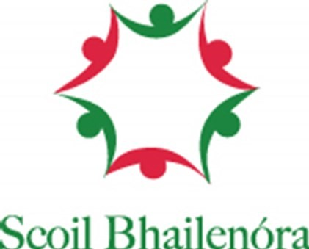
Application Form Scoil Bhailenóra

Applications open from 1st October to 22nd October 2023

Question 1
Child's name as per birth cert. If child goes by another name please put in brackets. *
___________________________________________________________________

Question 2
Child's Date of Birth *
___________________________________________________________________

Question 3
Address - including Eircode please (proof of address may be required) *
___________________________________________________________________

Question 4
Class level pupil wishes to enrol in, e.g. Junior Infants, or 2nd class, or 5th class *
___________________________________________________________________

Question 5
Child's PPS number *
___________________________________________________________________

Question 6
Child’s gender
___________________________________________________________________

Question 7
Mother's name *
___________________________________________________________________

Question 8
Mother’s contact number *
___________________________________________________________________

Question 9
Mother’s email address *
___________________________________________________________________

Question 10
Father's name *
___________________________________________________________________

Question 11
Father’s contact number *
___________________________________________________________________

Question 12
Father’s email address *
___________________________________________________________________

Question 13
Have you applied to other primary schools? *
___________________________________________________________________ Question 14
Have siblings of this child attended Scoil Bhailenóra? *
___________________________________________________________________

Question 15
If 'yes' to question 14, please give sibling(s) names and years of attendance, eg. John Murphy 2000-2008
___________________________________________________________________

Please return this form to oifig@ballinorans.ie

Or

Scoil Bhailenóra
Waterfall,
Cork
T12D500

- All forms received after 5pm on 22nd October will be considered late applications.
- Please answer all All questions marked * for forms to be considered completed.

You are welcome to hand deliver to the office.

We look forward to working with your family over the coming years and seeing your child develop and grow.

Le gach-dea-ghuí
Luke Foley and all in Scoil Bhailenóra

